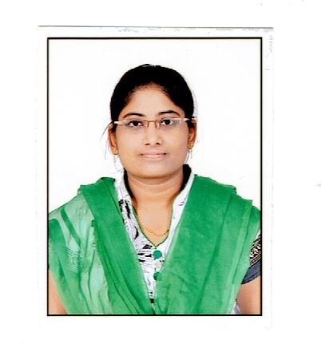

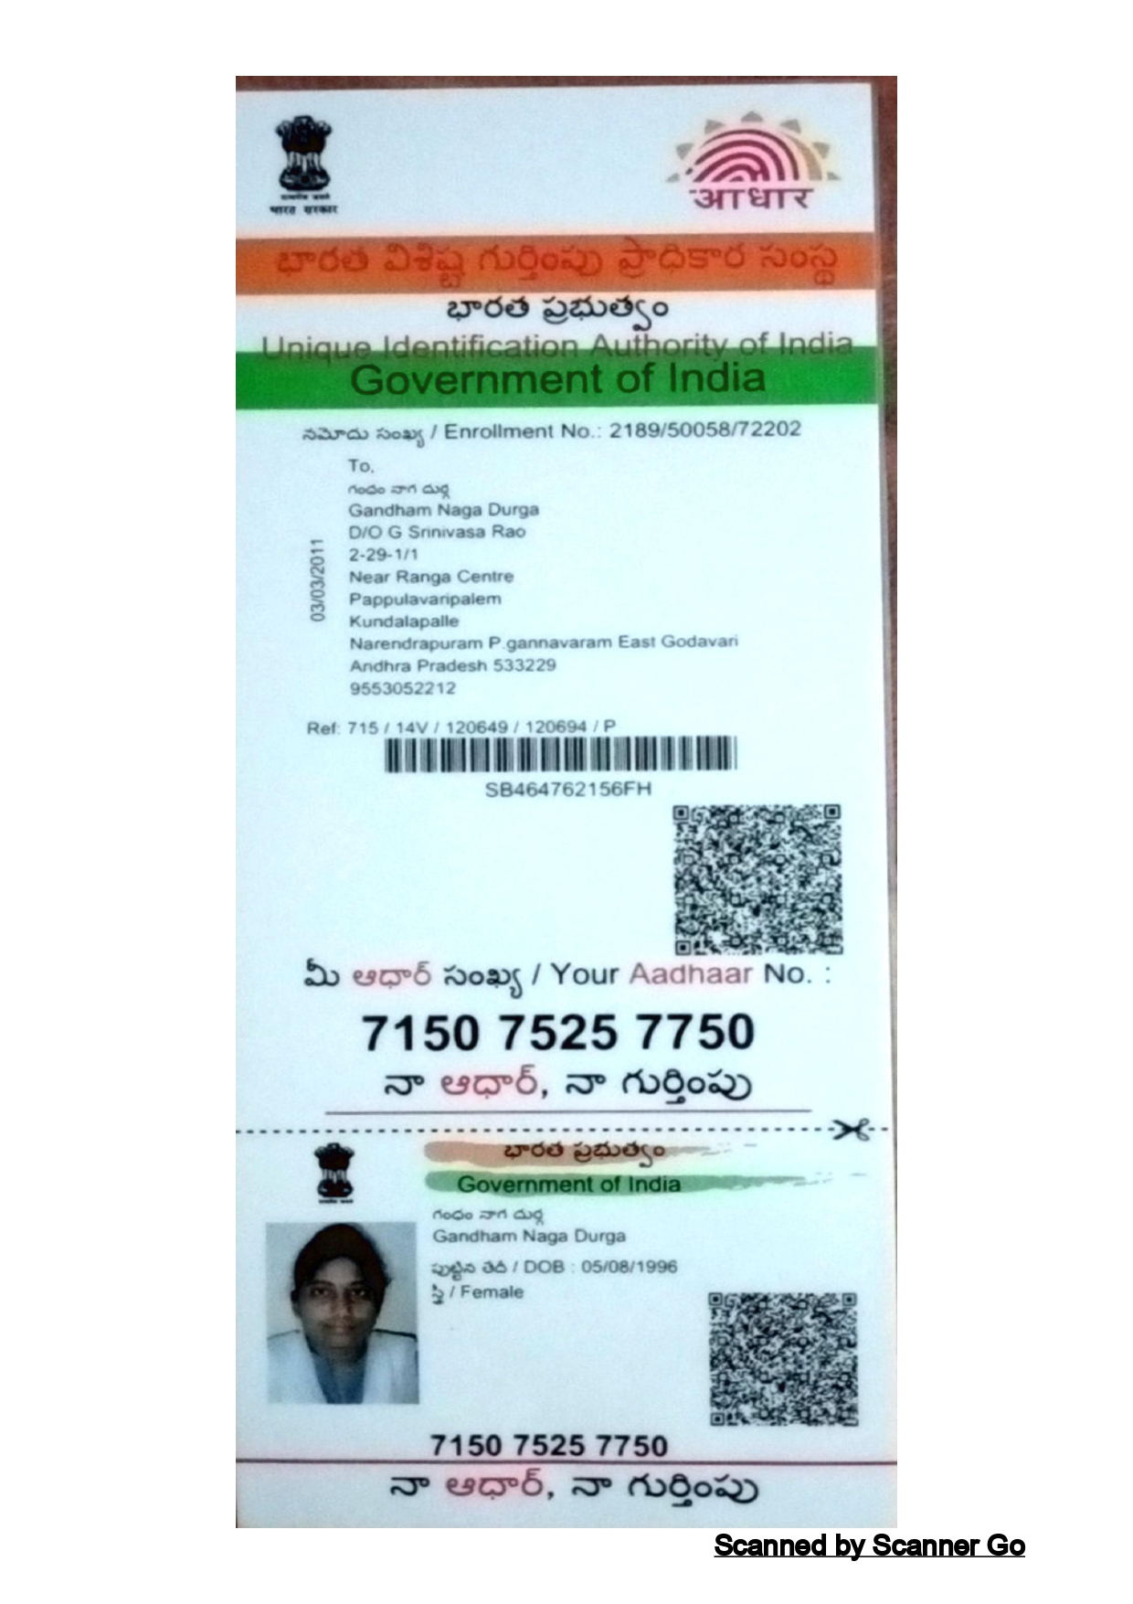

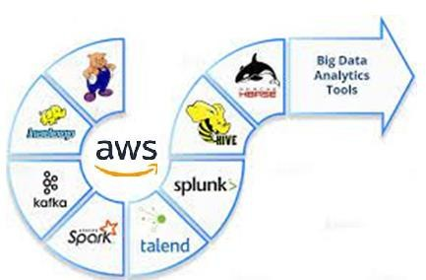
www.linkedin.com/in/gandhamnagadurga

NAGA DURGA G
Phone: (+91)-9148050548
nagadurgach2022@gmail.com

PROFESSIONAL SUMMARY

- Having 4 years of experience in designing, developing and maintaining large business applications such as data migration, integration, conversion, and Testing and last 1.3 years ago,I started working with Data application team where I have spark and SQL rigorously.
- Exposure in design and development of solutions for Big Data using the Hadoop eco system technologies (HDFS,Hive,Sqoop,ApacheSpark,AWS)
- Worked extensively on Hadoop migration project and POCs.
- Manned versatile roles across diverse applications as Data Engineer and Developer.
- Capable of processing large sets of Structured, Semi-structured and Streaming data
- Brought in simplification process and Optimization initiatives to bring efficiency into applications.
- Experienced big data engineer with a proven track record of success in developing and deploying large-scale data processing pipelines on AWS.
- Expertise in using Spark, EMR, S3, Hadoop, and Sqoop to build and manage data lakes and data warehouses.
- Strong understanding of big data concepts and technologies, including data modeling, data warehousing, and data analysis.
- Ability to work independently and as part of a team to deliver high-quality results.
- Deep knowledge in incremental imports, partitioning and bucketing concepts in Hive and Spark SQL needed for optimization.
- Ability to work independently and as part of a team to deliver high-quality results.
- Excellent problem-solving and troubleshooting skills.
- Developed a Spark application to process and analyze data from a large Hadoop cluster.
- Managed an EMR cluster that was used to process data from a variety of sources, including S3, MySQL, and Oracle.
- Built a data lake on S3 that was used to store and analyze data from a variety of sources.
- Used Sqoop to transfer data from a MySQL database to an EMR cluster.
- Implemented partitioning and bucketing in Hive for better organization of the data.
- Experience collecting log data from various sources and integrating it into HDFS using Flume; staging data in HDFS for further analysis.

- Create and maintain ETL specifications and process documentation to produce the required data deliverables (data profiling, source to target, ETL flows)
- Designed and developed Spark applications to implement complex data transformations and aggregations for batch processing jobs, leveraging Spark SQL and DataFrames.
- Have strong Interpersonal skills, communication skills to manage as a team lead.

TECHNICAL SKILLS

Data Eco System : Hadoop,Sqoop,Apache Spark
Cloud Skills : AWS
Distribution : Cloudera ,Eclipse.
Databases : MS SQL Server, MySQL
Languages : Scala,Python,SQL Operating Systems : Linux and Windows

PROFESSIONAL EXPERIENCE

Project Name:BYJU’S BNAT Campaign. Feb 2022 – April,2023

Project Role: Data Engineer Responsibilities
- Analyzed the requirements and performed Impact Analysis based on the requirements
- Maintaining data pipeline.
- Have strong experience in SQL including query optimization,best practices
- Involved in applying transformation with SQL based on business Logic in the Mapping sheet
- Involved in modifying existing Procedures and ETL workflows according to the new business needs using Microsoft SQL server Manager.
- Well versed in cloud technologies preferably AWS services.
- Knowledge of Spark DataFrame best practices in data engineering and data science domains, such as data preprocessing, feature engineering, model training, and inference
- Designed and developed batch processing data pipelines on Amazon EMR using Apache Spark, Python, and Scala to process terabytes of data in a cost-effective and scalable manner
- Experience working with Spark DataFrame in production environments and implementing performance monitoring and alerting systems to detect and resolve performance issues proactively.
- Experienced in working with large dataset,querying terabytes of data on a regular basis.
- Involved with general big data technologies like HDFS,Sqoop,airflow,Apache Spark.
- Familiarity with Spark DataFrame APIs and SQL syntax and ability to write complex SQL queries and DataFrame operations to solve business problems
- Understands detailed requirements and demonstrates excellent problem solving skills.
- Performed Import and Export of data into HDFS and Hive using Sqoop and managed data within the environment.

- Skilled in using Spark SQL persistency and caching mechanisms to reduce data processing overhead and improve query performance.
- Experienced in importing and exporting large datasets between Hadoop and relational databases using Sqoop.
- Proficient in writing Sqoop commands to transfer data between Hadoop and various databases such as MySQL, and SQL Server.
- Skilled in implementing Sqoop-based solutions for migrating data between different Hadoop distributions and versions.
- Strong experience in configuring Sqoop to handle complex data structures such as nested and hierarchical data.
- Proficient in using Sqoop to perform data validation and reconciliation checks to ensure data accuracy and completeness.
- Experienced in setting up and configuring Sqoop-based data import and export solutions for large- scale data warehousing projects.
- Familiarity with Spark SQL schema and data type operations, such as creating, modifying, and dropping tables, views, and indexes, and handling null values
- Maintained and monitored Spark clusters on AWS EMR, ensuring high availability and fault tolerance.
- Was responsible for Optimizing Sparksql queries that helped in saving Cost to the project.
- Loaded and transformed large sets of semi structured data likes XML,JSON,Avro,Parquet.
- Generated complex JSON data after all the transformations for easy storage and access as per client requirements.
- As per the business requirement storing the spark processed data in HDFS/S3 with appropriate file formats.
- Performed Import and Export of data into HDFS and Hive using Sqoop and managed data within the environment.
- Involved in creating Hive tables, data loading and writing hive queries.
- Was responsible for Optimizing Hive queries that helped in saving Cost to the project.
- Managed Hive Tables and created child tables based on partitions.
- Involved in working on the Data Analysis, Data Quality and data profiling for handling the business that helped the Business team.

Technologies: Spark, Python, HDFS, Hive, AWS

Project Name :Marriott Dec ,2019 - Jan,2022

Project Role: Data Engineer Responsibilities:

- Designed and implemented scalable and high-performance big data pipelines using technologies such as Hadoop, Spark, and Kafka.

- Developed ETL processes to extract, transform, and load large volumes of data from various sources into Hadoop or other distributed storage systems.
- Implemented data processing and analysis using distributed computing frameworks like Spark, leveraging Spark DataFrames and RDDs.
- Designed and optimized data models and schemas for efficient storage and retrieval in Hadoop or NoSQL databases.
- Collaborated with cross-functional teams to understand data requirements and provided solutions for data ingestion, processing, and analysis.
- Implemented data governance and security measures to ensure data integrity, confidentiality, and compliance with regulatory standards.
- Conducted performance tuning and optimization for big data processing workflows, including query optimization and resource management.
- Automated data workflows and job scheduling using tools like Apache Airflow or Oozie to improve operational efficiency.
- Kept abreast of emerging big data technologies and trends, evaluating and recommending suitable tools for specific use cases.
- Collaborated with data engineering teams to ensure data quality, consistency, and availability for analysis purposes.
- Conducted exploratory data analysis to identify trends, patterns, and correlations in the data.
- Implemented statistical analysis and machine learning techniques to solve business problems and derive predictive insights.
- Worked closely with business stakeholders to understand their requirements and provided actionable recommendations based on data analysis.
- Applied data visualization techniques to effectively present analysis results and findings to both technical and non-technical audiences.
- Participated in the development and maintenance of data governance processes and standards.

WORK EXPERIENCE

- BYJU’S Think& Learn Pvt.Ltd.-Feb,2022– April,2023
- Novitas Technologies Private Ltd.-Dec ,2017 - Jan,2022

EDUCATION

Institute/College | Duration | Percentage Obtained
Swarnandhra college of Engineering  &Technology(JNTU-KAKINADA) | 2013-2017 | 78.3%
Aditya Junior college | 2011-2013 | 94.3%
OXFORD Kennedy High School | 2010-2011 | 88.3%

